
FACULTY OF INFORMATION TECHNOLOGY
2025 DATABASES 600
ASSIGNMENT
richfield.ac.za

Name and Surname: Matthew Magadza
Student ITS No: 402310062
Qualification: BSCIT Year of Study: 2025 Semester: 1

Assignment due date: Date submitted
QUESTION | EXAMINER MARKS | MODERATOR MARKS | REMARKS
ASSIGNMENT INSTRUCTIONS
Please tick each box to confirm completion. (10 Marks)
Use Times New Roman font, size 12, with 1.5 line spacing throughout the document. Apply Harvard Referencing Style for all citations and references.
For essay-style assignments, please include the following sections:
Table of Contents Introduction
Main Body (with relevant subheadings) Conclusion
References
Submit the assignment in PDF format on Moodle. Use the specified cover page provided.
Include a signed declaration of originality.

DECLARATION OF ORIGINALITY:
I hereby declare that this assignment is my own work and has not been copied from any other source except where due acknowledgment is made. I affirm that all sources used have been properly cited and that this submission complies with the institution’s policies on academic integrity and plagiarism.
Student Signature: MTM Date:

Contents
No table of contents entries found.

Question 1
Transitioning to a digital database Management System (DBMS) from a paper-based system will greatly improve how data is handled. Paper systems are slow, easy to lose, damage, and hard to organize (Watt,2022). A DBMS stores data digitally, offering a faster access, better security, and easy updates (Kumar,2025). The paper files will need to be found and sorted by hand while a DBMS uses digital tables which are easy and fast to search though (Kumar, 2025; Bergsteinsson, 2023). Paper records tend to be inconsistent and the DBMS will reduce errors with rules and keep the data safe by using passwords, user role such as admins, and developers, and general users (Nelson,2023; Watt, 2022; AgilitySytem,2023).Updating paper records takes time and requires more space than A DBMS which handles large amounts of data quickly and automatically backs up information (ScalableDB, 2024). The components we will need other than the users we will need computers and storage devices (InterviewBit, 2023) such as hard drives or solid state drives(SSD),software like MySQL SQL server and mango dB which are examples of database engines and tools (Nelson, 2023) , We will store the data in tables and metadata (Marques, 2025), we have to create Guidelines for managing the DBMS (Nelson, 2023), and we will need to use a language like SQL to query from the DBMS (InterviewBit, 2023).The function of DBMS are Data Definition :Set up and change data structures (Marques, 2025). Data manipulation : adding, editing, or deleting data (Taylor, 2025). Data retrieval: though searching and queries efficiently (Marques, 2025).Administration: controlling access and managing backups (AgilitySystem, 2023).
The advantages of DBMS
- Accurate and consistent data (Kumar, 2025)
- Very secure (AgilitySystem, 2023)
- Quick access to the data (Taylor, 2025)
- Easy to scale (ScalableDB, 2024)
- Automatic backups and recovery (Marques, 2025)
The disadvantage of DBMS
- It is Expensive to install and maintain (Taylor, 2025)
- If extra features are added it may slow down (Marques, 2025)
- Needs regular updates (Nelson, 2023)

Question 2

2.1 Creating the Student Table
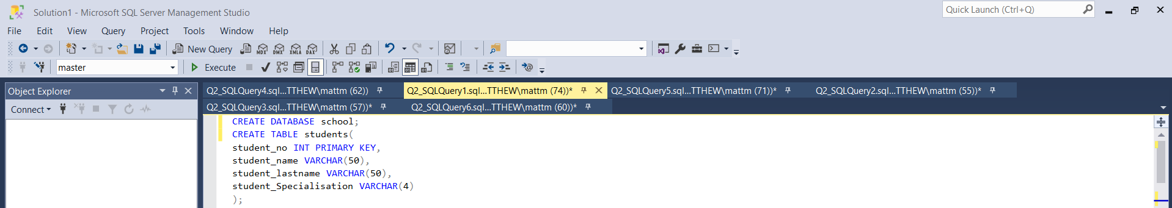
The CREATE TABLE command is used to define the structure of the students table with the 4 fields: a unique Student_Number, Student_Name, Student_Surname, and Student_Specialisation. The Student_Number is defined as the primary key, which ensures that each student record is uniquely identifiable (Coronel and Morris, 2019).
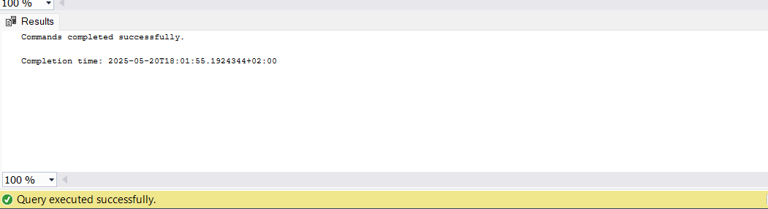

2.2 Inserting Given Data
